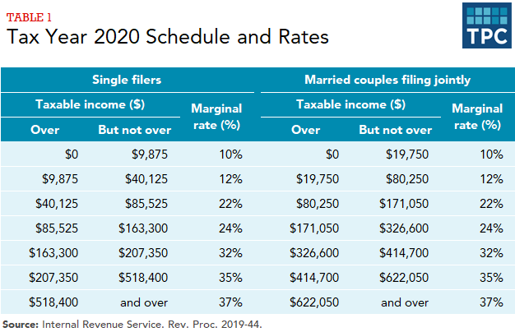

Why are those who are poor and less fortunate still responsible to pay taxes at all? What is made over a livable wage is meant to be a luxury of good fortune and reward for your participation in society. Those who are fortunate enough to do more than merely survive in this world should gladly help those less fortunate to succeed. Until we can give our time and attention to better our own lives and those of the ones we care for, humanity will never flourish and grow. We have to have the freedom to take the time to care for our physical, mental, and emotional state to reach our best self to offer the world.

What if every household (single adult) and any additional working adult were divided into income brackets as such:

$0<$50k = Under Income
$50k<$100k = Livable Income
$100k< = Taxable Income

Each dependent (child or adult regardless of circumstance or income level) increases household income limit an additional $5k not to exceed 10 dependents per household.

(Must be 18+ and actively employed 20+ hours per week in order to not be considered a dependent)

Filers UNDER INCOME receive payment to ensure yearly income is equal to minimum income threshold ($50k per adult filer + $5k per dependent, not to exceed $50k for dependent income limit increase per household)

Filers of a LIVABLE INCOME, $50k-$100k, are not held liable for additional taxes beyond sales taxes imposed.

Filers of a TAXABLE INCOME would ALL be liable to 50% federal income tax on all income above $100k.

Tax breaks could be awarded for continued education and skill training, healthy lifestyle and habits, volunteering, and other ways we work to better ourselves and the world around us.

